**Feedback Control Systems**

**Lab Report 14**

**Hafiz Ahmad**

**19l-1316**

**Section-6B2**

**Compensator Design using Root Locus**

**Introduction:**

The experiment is designed to understand the graphical procedure for determining the stability of a control system based on root locus. MATLAB Control system toolbox contains two root locus design GUI, sisotool and rltool. The main aim of this experiment is to use the SISO toolbox to understand and design the compensators using root locus design.

**Objective:**

* To successfully design a compensator to meet the transient response and steady state error performance specifications

**Procedure :**

For the unity feedback system, $G_{p}(s)=\frac{1}{s(s+2)(s+5)}$ design a phase lead compensator

$$G_{c}(s)=\frac{K_{c}(s+z_{c})}{(s+p_{c})}$$

For the following time domain specifications:

* Dominant poles damping ratio=0.707
* Dominant poles settling time=2sec

Simulation:

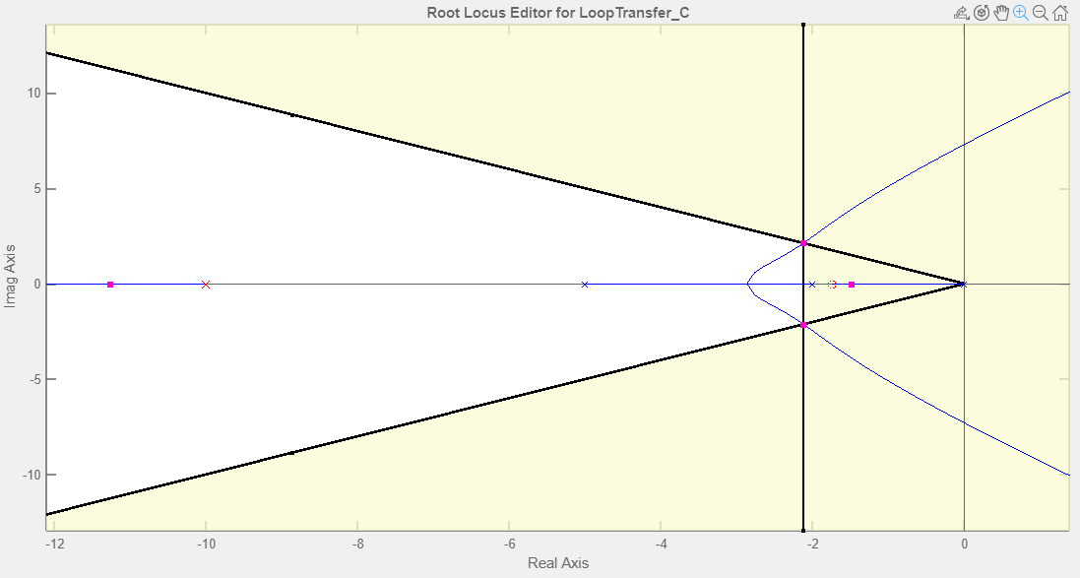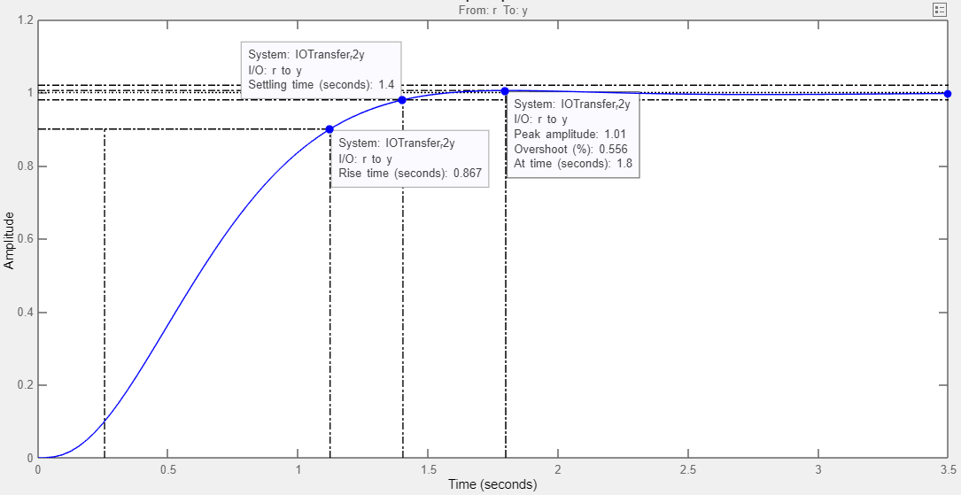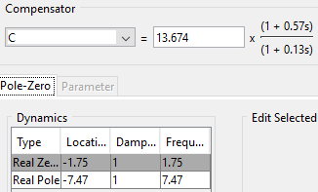

Observations:

|  |  |
| --- | --- |
| Transfer function of Lead Compensator | (s+1.75)/(s+7.47) |
| Transfer function of Compensated System | (s+1.75)/(s)(s+2)(s+5)(s+7.47) |
| Damping ratio | 0.7 |
| Settling time | 1.4 |

Ex1

Re-evaluate the system’s performance when the lead compensator’s zero is placed at -2 in example above.

Simulation:

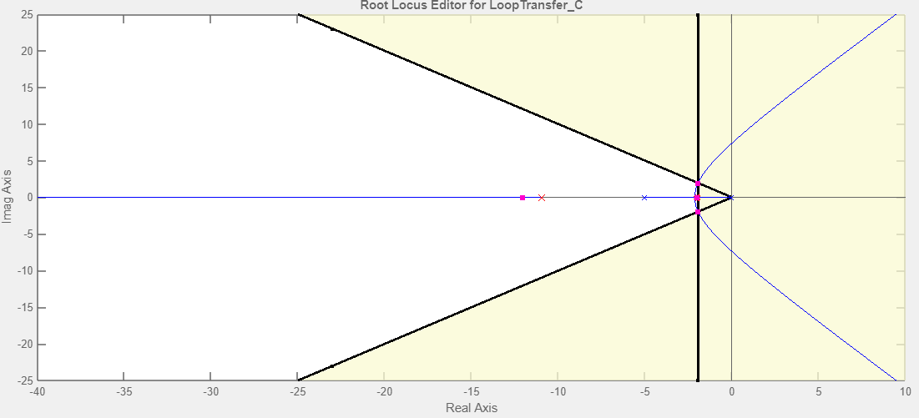

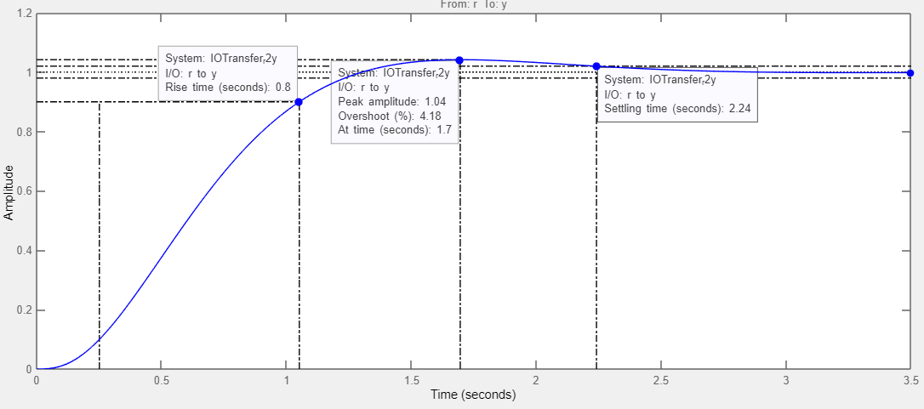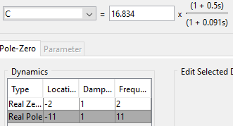

Observations:

|  |  |
| --- | --- |
| Transfer function of Lead Compensator | (s+2)/(s+11) |
| Transfer function of Compensated System | (s+2)/(s)(s+2)(s+5)(s+11) |
| Damping ratio | 0.78 |
| Settling time | 2.24 |

Q-2: A unity feedback system has open loop transfer function

$$G\left(s\right)H(s)=\frac{4}{s(s+2)}$$

It is desired that dominant closed loop poles provide damping ratio=0.5 and have an un-damped natural frequency 4rad/sec. Velocity error constant is required to be 40.

Verify that only gain adjustment cannot meet these objectives.

Proof:

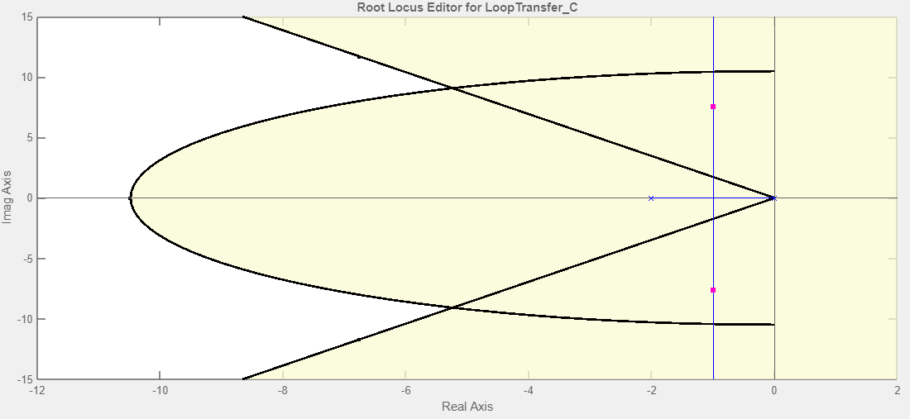

As point of intersection is not the part of root locus so it cannot be achived by gain adjustment

Design 1

1. Design a lead compensator using SISO design tool to meet the objectives, when compensator zero is placed at -1.
2. Using GUI, determine the peak overshoot and settling time of the lead-compensated system.

Simulation:

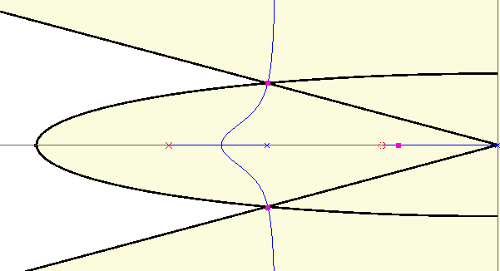

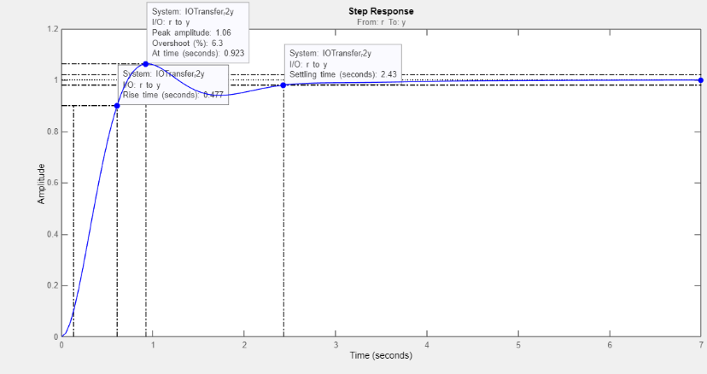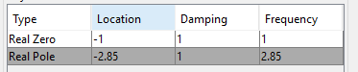

Observations:

|  |  |  |
| --- | --- | --- |
| *Transient response* | *Value* | *Units* |
| Peak Overshoot | 6.3 | $$\%$$ |
| Settling Time | 2.43 | $$s$$ |
| Peak Time | 0.923 | $$s$$ |

Design 2

1. Design a lead compensator using SISO design tool to meet the objectives, when compensator zero is placed at -2.
2. Using GUI, determine the peak overshoot and settling time of the lead-compensated system.

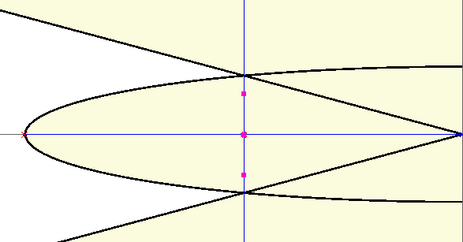

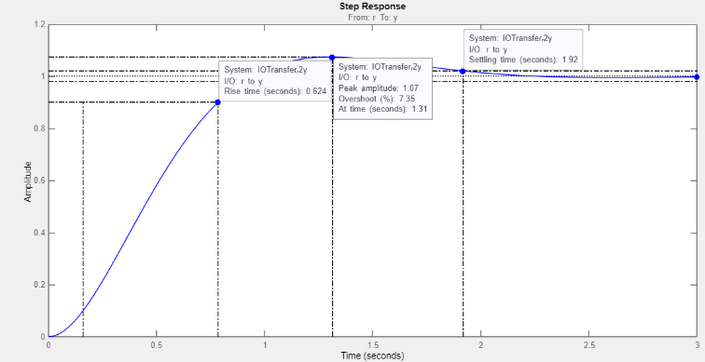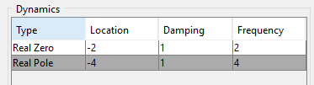

Observations:

|  |  |  |
| --- | --- | --- |
| *Transient response* | *Value* | *Units* |
| Peak Overshoot | 7.35 | $$\%$$ |
| Settling Time | 1.92 | $$s$$ |
| Peak Time | 1.31 | $$s$$ |

**Conclusion:**

After performing different types of operation on the root locus while designing the compensator. We know how to value design a compensator and what are their basic requirements, also calculated damping ratio and settling time of system.

**Application:**

The Root Locus Plot technique can be applied to determine the dynamic response of the system. This method associates itself with the transient response of the system and is particularly useful in the investigation of stability characteristics of the system.

**Issues:**

No issue occured .

**Post Lab:**

**Use the following plant:**

$$P\left(s\right)=\frac{8.96}{{0.00147s}^{2}+ 0.01455s+1}$$

**Simulate its step response. Using a Lead Compensator, try to get the settling time to less than 0.5 sec (approx. 0.1 sec) while keeping the %OS lesser than 10%. Justify your design in the report.**

**Root Locus with design requirements**

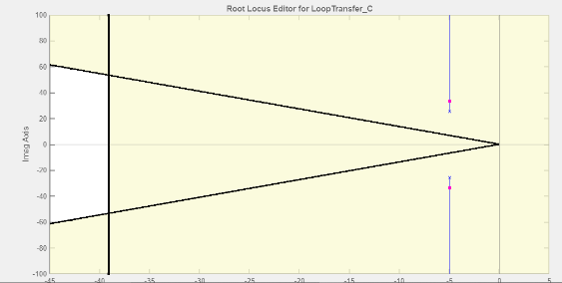

Compensated Root locus

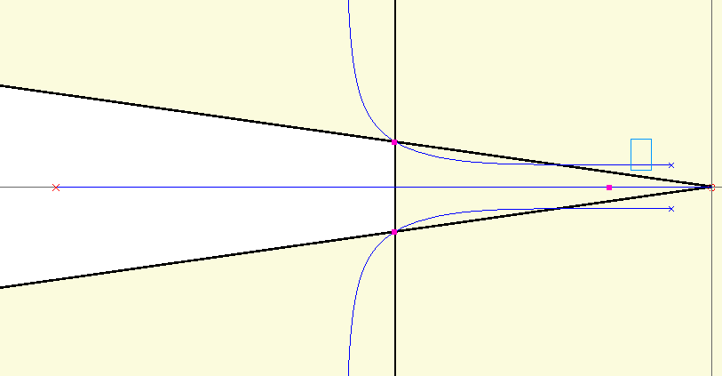

Step Response

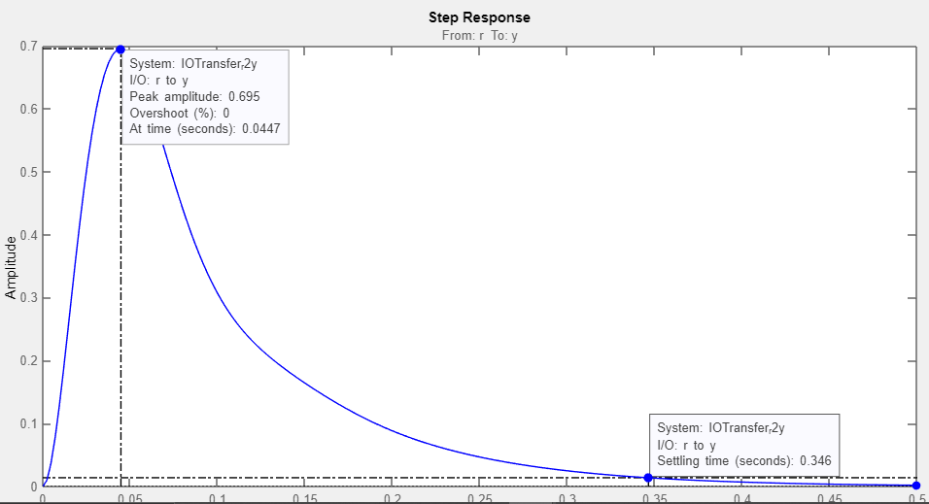

Compensator values:

